AWS EBS Snapshot & Disaster Recovery Project
Amazon Elastic Block Store (EBS) snapshots are point-in-time copies of data stored on Amazon EBS volumes in the Amazon Web Services (AWS) cloud. EBS snapshots are used for backup, recovery, and data migration.

• STEP 1: CREATE AN EC2 INSTANCE
- Go to AWS Console and create an EC2 instance based on Linux machine.
- Create the instance in a different availability zone than your prior operating instances.

• STEP 2: CREATE AN EBS SNAPSHOT
- To create an EBS Snapshot, go to EBS Volumes.
- There you will your 16gb of volume which you have created before and that volume is mounted to another instance.
- Select that volume then click on actions, then click on create snapshot.
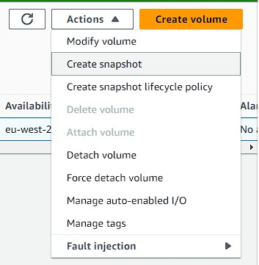

4. While creating a snapshot the only thing you need to do is, give it a name.
5. Then click on create snapshot..
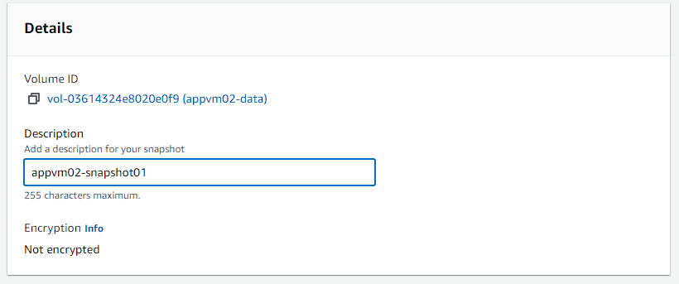

6. Now go to snapshots, there you will see your newly created snapshot.
7. Currently it is in pending state, wait for time to let the progress to get completed
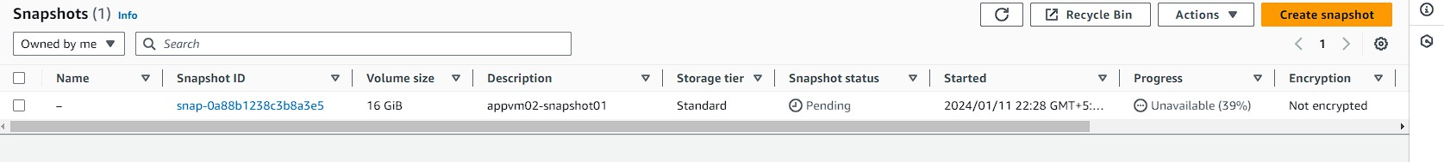
8. Once your snapshot is available, then you need to select this snapshot and click on actions.
9. Now from the actions’ menu you can create a volume out of this snapshot.
10. So, click on create volume from snapshot
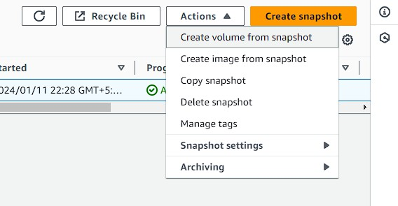

11. The process is same to create the volume. You need to select a volume type then size is fixed.
12. The only major this here is you need to select the same availability zone as your instance on which you are going to attach this volume.
13. Then click on create volume.
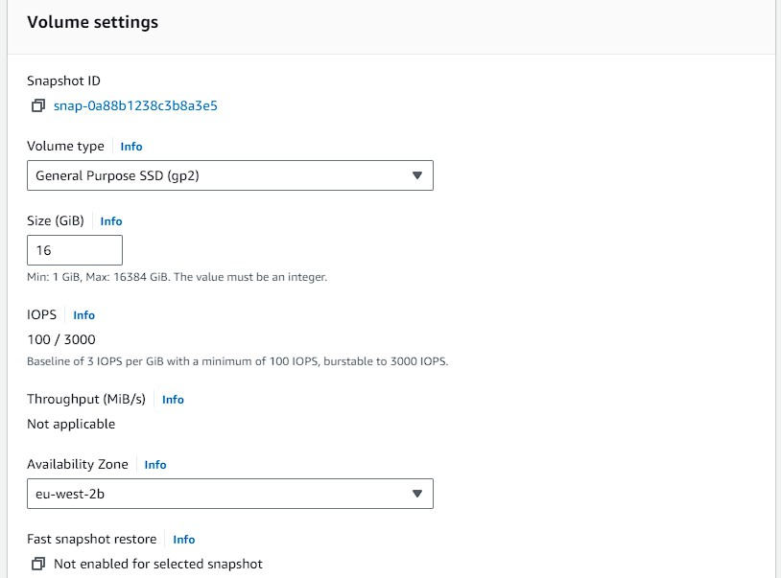
14. So, now if you go back to volumes, there you will see your new volume, just rename it and attach it with the instance

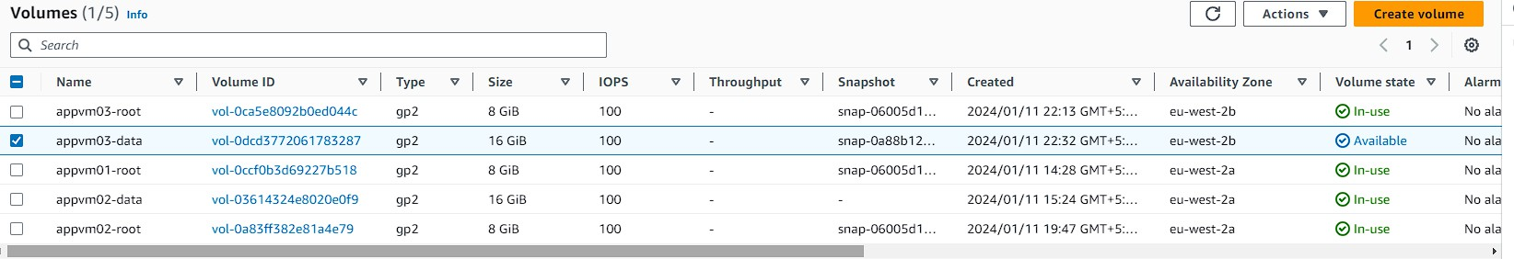

STEP 3: LOGIN TO INTANCE AND MOUNT THE VOLUME
- After attaching the volume to your snapshot. Now you have to log in to your instance using putty.
- First do a listing of bulk drives. Then create a directory for your volume.
- After that mount the volume with your directory.
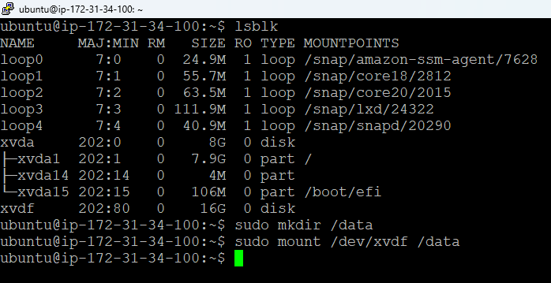
4. Now go into your directory. There does a listing of files that exist in this volume, because you have created this volume from a snapshot.
5. So, the data which was store into this volume should be in here.
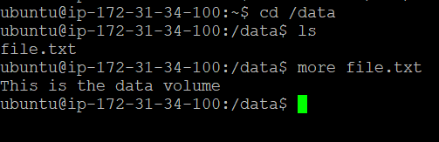

NOW FOR THE CLEAN UP PROCESS.
FIRST YOU NEED TO UNMOUNT THIS VOLUME FROM THIS INSTANCE
AFTER THAT GO BACK TO THE CONSOLE AND DETACH THE VOLUME FROM YOUR INSTANCE. ONCE YOUR VOLUME HAS BEEN DETACHED DELETE IT.
THEN DELETE YOUR SNAPSHOT ALSO. AND TERMINATE YOUR INSTANCE

